SEG Awards Level 2

Motor Vehicle Studies

Underpinning Knowledge Evidence Record

K/601/6237 Knowledge of Materials, Fabrication, Tools and Measuring Devices used in the Automotive Environment

Learners Name
SEG Awards Registration Number
Centre Name
Assessor 1 Name
Assessor 2 Name

DECLARATION OF AUTHENTICITY

This declaration must be completed and signed by the learner and countersigned by the tutor / assessor and covers all evidence submitted for moderation.

Learner Name
Unique Learner Number (ULN) |  | SEG  Learner Reg. ID
Qualification Title
Centre Name

Learner statement of authenticity

Before signing please read the guidance below.

I confirm, that the attached assignment / portfolio is all my own work and does not include any work completed by anyone other than myself. I have completed the assignment / portfolio in accordance with SEG Awards’ instructions and within the time limits set by my centre.

Signature |  | Date

Centre confirmation of authenticity

On behalf of …………………………………….(insert centre name), I confirm that the above mentioned learner, to the best of my knowledge, is the sole author of the completed assignment / portfolio attached, and the assessments have been completed under the required conditions.

Signed |  | Date
Name
Title

Guidance for Learners

You have been asked to sign this Declaration of Authenticity and place it at the front of your portfolio or course work assessment. It confirms that the work you have submitted for assessment is your own and that you have not copied it from someone else or allowed another learner to copy it from you.

When preparing any course work it is good practice to undertake research using information from published sources. If you quote directly from these sources then this must be indicated in your work by using quotation marks and referencing the document from which the quotation was taken. You must then comment in your own words on any ideas expressed.

Assessors, internal verifiers and SEG Awards’ external moderators and verifiers are subject specialists who can spot the use of published materials that may be passed as your own words or ideas.
If you do copy words from a published source and do not indicate their reference you will be committing plagiarism. This is considered a form of cheating and may result in your assessment being declared void.

Contents

Task No | Title | Assessment Criteria
1 | Hand tools | 1.1, 1.3, 1.5
2 | Measuring devices | 1.2, 1.3, 1.5
3 | Workshop equipment | 2.2
4 | Properties of materials | 3.1, 3.2, 3.3
5 | Fabricating | 4.1, 4.2, 4.3
6 | Locking and fastening | 4.4, 4.5

Task 1 – Hand tools | Assessment Criteria 1.1, 1.3, 1.5

Identify the types of spanners/wrenches below
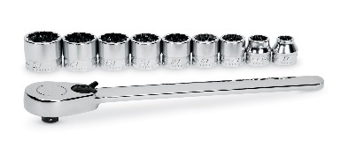 | 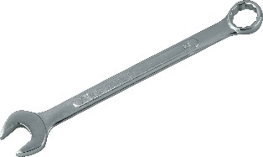 | 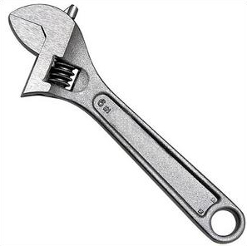 | 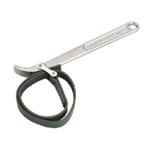
Name | Name | Name | Name

Identify the types of pliers below
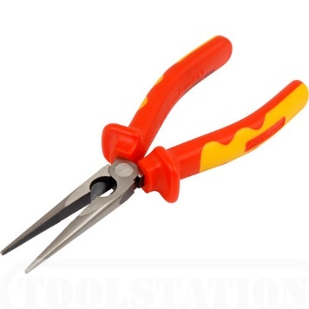 | 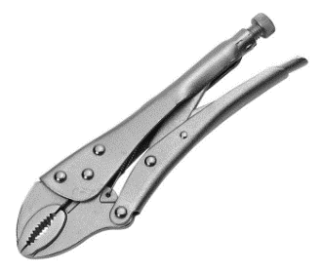 | 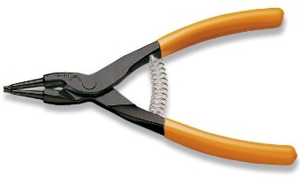 | 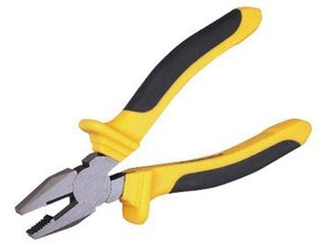
Name | Name | Name | Name

Identify the types of screwdriver below
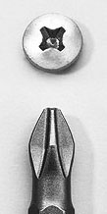 | 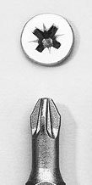 | 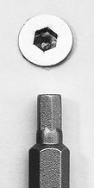 | 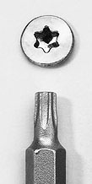 | 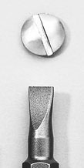
Name | Name | Name | Name | Name

State how to correctly store and maintain hand tools

Identify the drilling and thread forming tools and their uses in the table below
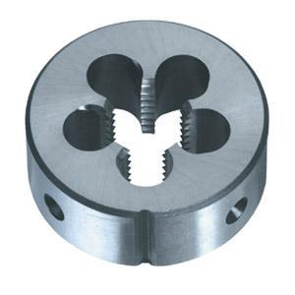 |  | 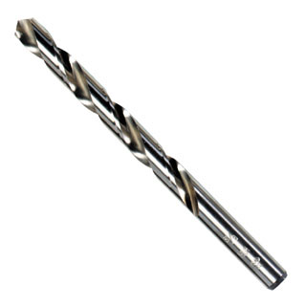
Name |  | Name
Use |  | Use
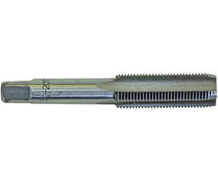 |  | 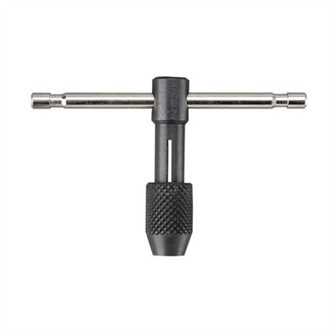
Name |  | Name
Use |  | Use

Task 2 – Measuring devices | Assessment Criteria 1.2, 1.3, 1.5

Below is a selection of measuring devices commonly used in the automotive environment, identify the types of measuring devices in the box provided and their limit of accuracy
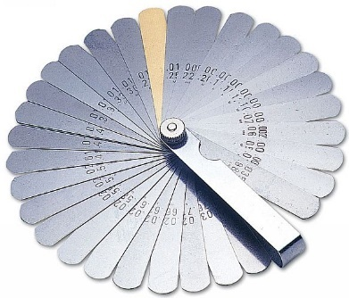 |  | 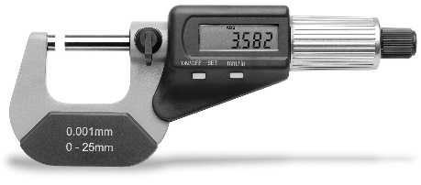 |  | 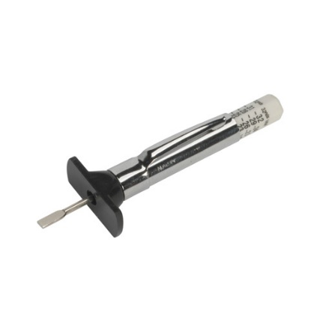
Name |  | Name |  | Name
limit of accuracy |  | limit of accuracy |  | limit of accuracy
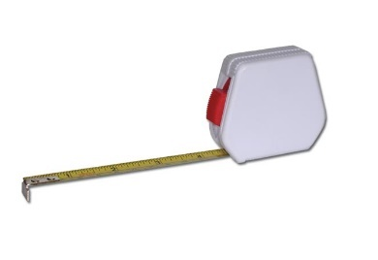 |  | 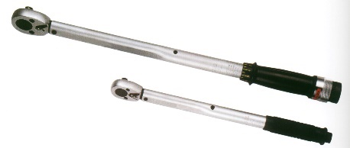 |  | 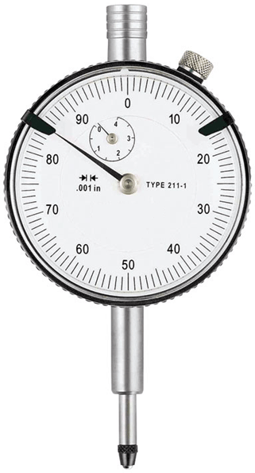
Name |  | Name |  | Name
limit of accuracy |  | limit of accuracy |  | limit of accuracy

State how to correctly store and maintain measuring devices

Task 3 – Workshop equipment | Assessment Criteria 2.2

Identify the workshop equipment below and state their use in the box provided
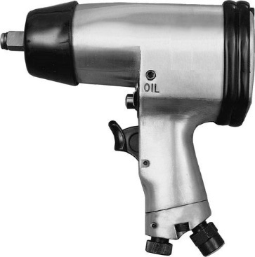 |  | 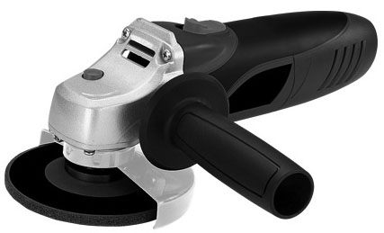 |  | 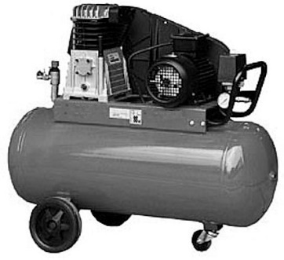
Name |  | Name |  | Name
Use |  | Use |  | Use
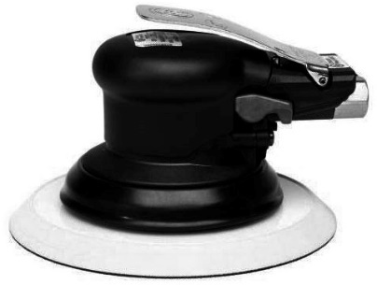 |  | 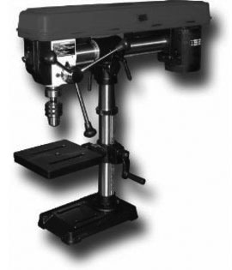 |  | 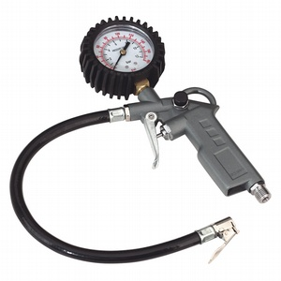
Name |  | Name |  | Name
Use |  | Use |  | Use

Identify the workshop equipment below, state their use and a suitable safety check in the boxes provided
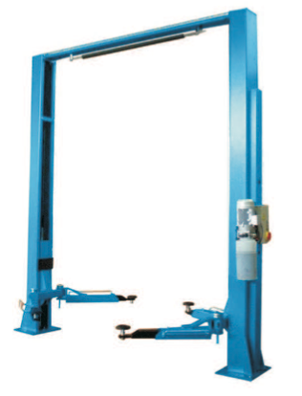 |  | 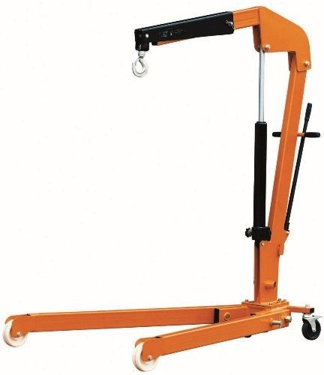 |  | 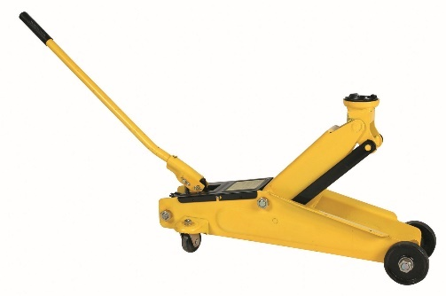
Name |  | Name |  | Name
Use |  | Use |  | Use
Safety Check |  | Safety Check |  | Safety Check

Describe what is meant by the term ‘Safe Working Load’?

Identify the electrical test equipment and their uses in the table below
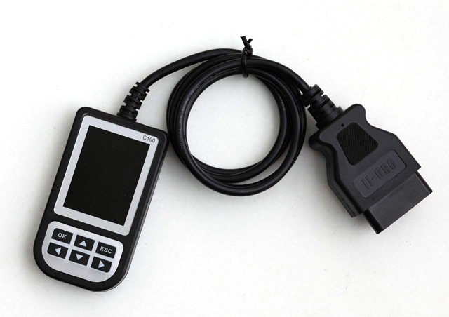 |  | 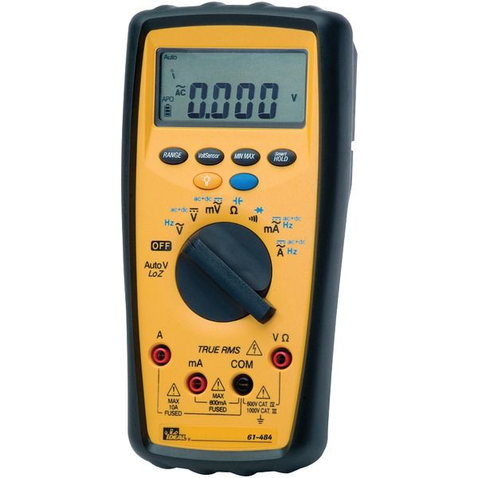
Name |  | Name
Use |  | Use
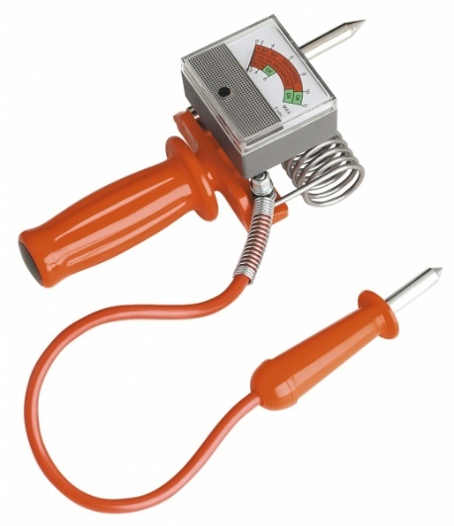 |  | 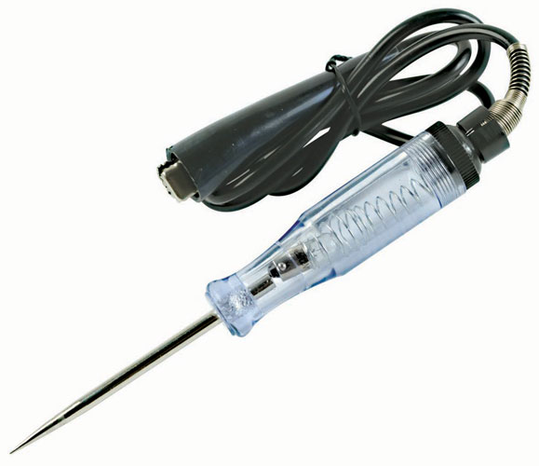
Name |  | Name
Use |  | Use

What precautions should be taken when using electrical test equipment?

Task 4 - Properties of materials | Assessment Criteria 3.1, 3.2, 3.3

In the table below provide the definition of the listed material properties
Property | Definition
Hardness
Toughness
Ductility
Elasticity
Malleability
Plasticity

The modern motor vehicle is constructed using a variety of metals and other materials and it is important to know where these materials are used.
The table below identifies some materials that are used in motor vehicles
- Complete the table by identifying the components that would be made from the material listed.

Metallic
Material | Properties |  | Limitations | Motor Vehicle Component
Steel
Alloy steel
Aluminium alloy
Cast iron
Copper
Non-Metallic
Material |  | Properties | Limitations | Motor Vehicle Component
Glass
Thermo-setting plastic
Thermo-plastic plastic
Kevlar
Rubber

Task 5 - Fabricating | Assessment Criteria 4.1, 4.2, 4.3

Describe how to tap a thread

Describe how to produce a thread on a round bar

In the table below identify the tools used to measure, mark out, shape and join materials when fabricating
Metals
 | Measure | Mark Out | Shape | Join
Tool
Plastics
 | Measure | Mark Out | Shape | Join
Tool

Describe the selection and fitting procedures of the following
Property | Selection | Fitting Procedures
Gaskets and seals
Sealants and adhesives
Fittings and fasteners
Electrical circuit components

Task 6 - Locking and fastening | Assessment Criteria 4.4, 4.5

Identify the locking devices below and state where each may be used
Locking Device | Name | Use
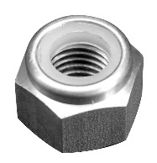
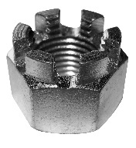
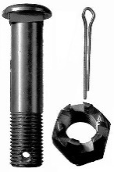
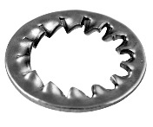
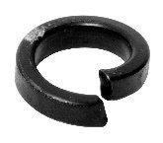

State why it is important to adhere to correct operating specifications for limits, fits and tolerances in the automotive environment

Unless otherwise stated e.g. for some entry level qualifications, learners can work together but should identify sections which are their own work.

